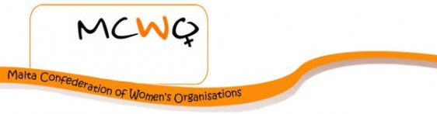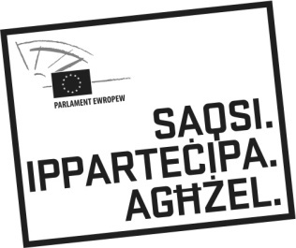
Malta Confederation of Women’s Organisations (MCWO)
c/o Keimar Bldg. Level 4, Giovanni Mamo Street, B’Kara BKR 2961
Tel:00356-79592626; 99426238
www.mcwo.net
e-mail: mail@mcwo.net;

Registration form
Seminar
EUROPEAN ELECTIONS 2014
GENDER PARITY IN DEMOCRACY : LET’S KEEP THE BALANCE!
Wednesday 2nd April 2014
Europa House, St Paul’s Street
Valletta
Email : mail@mcwo.net
Tel: 99426238

First name & Surname
Organisation
Postal Address

E-mail
Tel

This event might be filmed and a number of pictures will be taken for eventual use of media by the Press and also by the MCWO. If anyone does not wish to appear in the media kindly inform the MCWO accordingly.

