EVENT REPORT

WOMEN AND MIGRATION
in Europe & the Commonwealth of Independent States

UN House, Brussels on Wednesday, 04 November 2009

In celebration of the UN CEDAW’S 30TH anniversary,

The Convention on the Elimination of All Forms of Discrimination Against Women (CEDAW), adopted in 1979 by the UN General Assembly, is an international bill of rights for women. Consisting of a preamble and 30 articles, it defines what constitutes discrimination against women and sets agenda for national action to end such discrimination.
The Convention defines discrimination against women as "...any distinction, exclusion or restriction made on the basis of sex which has the effect or purpose of impairing or nullifying the recognition, enjoyment or exercise by women, irrespective of their marital status, on a basis of equality of men and women, of human rights and fundamental freedoms in the political, economic, social, cultural, civil or any other field."

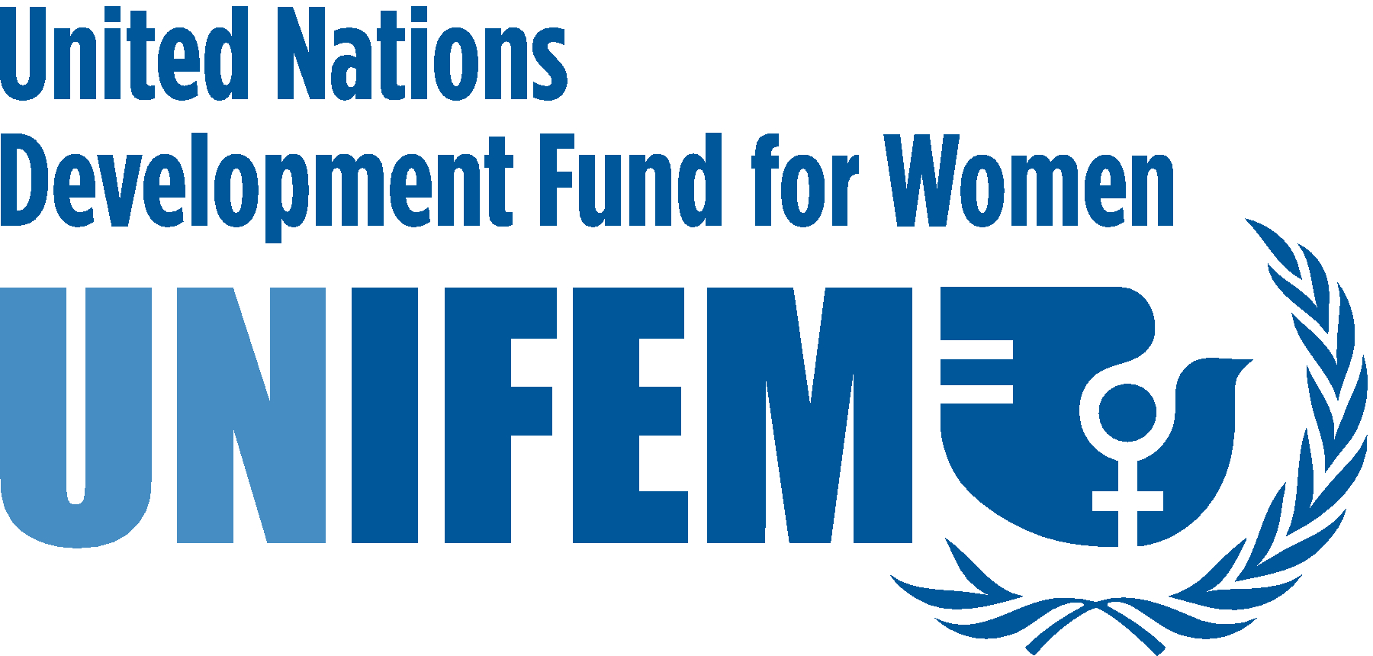
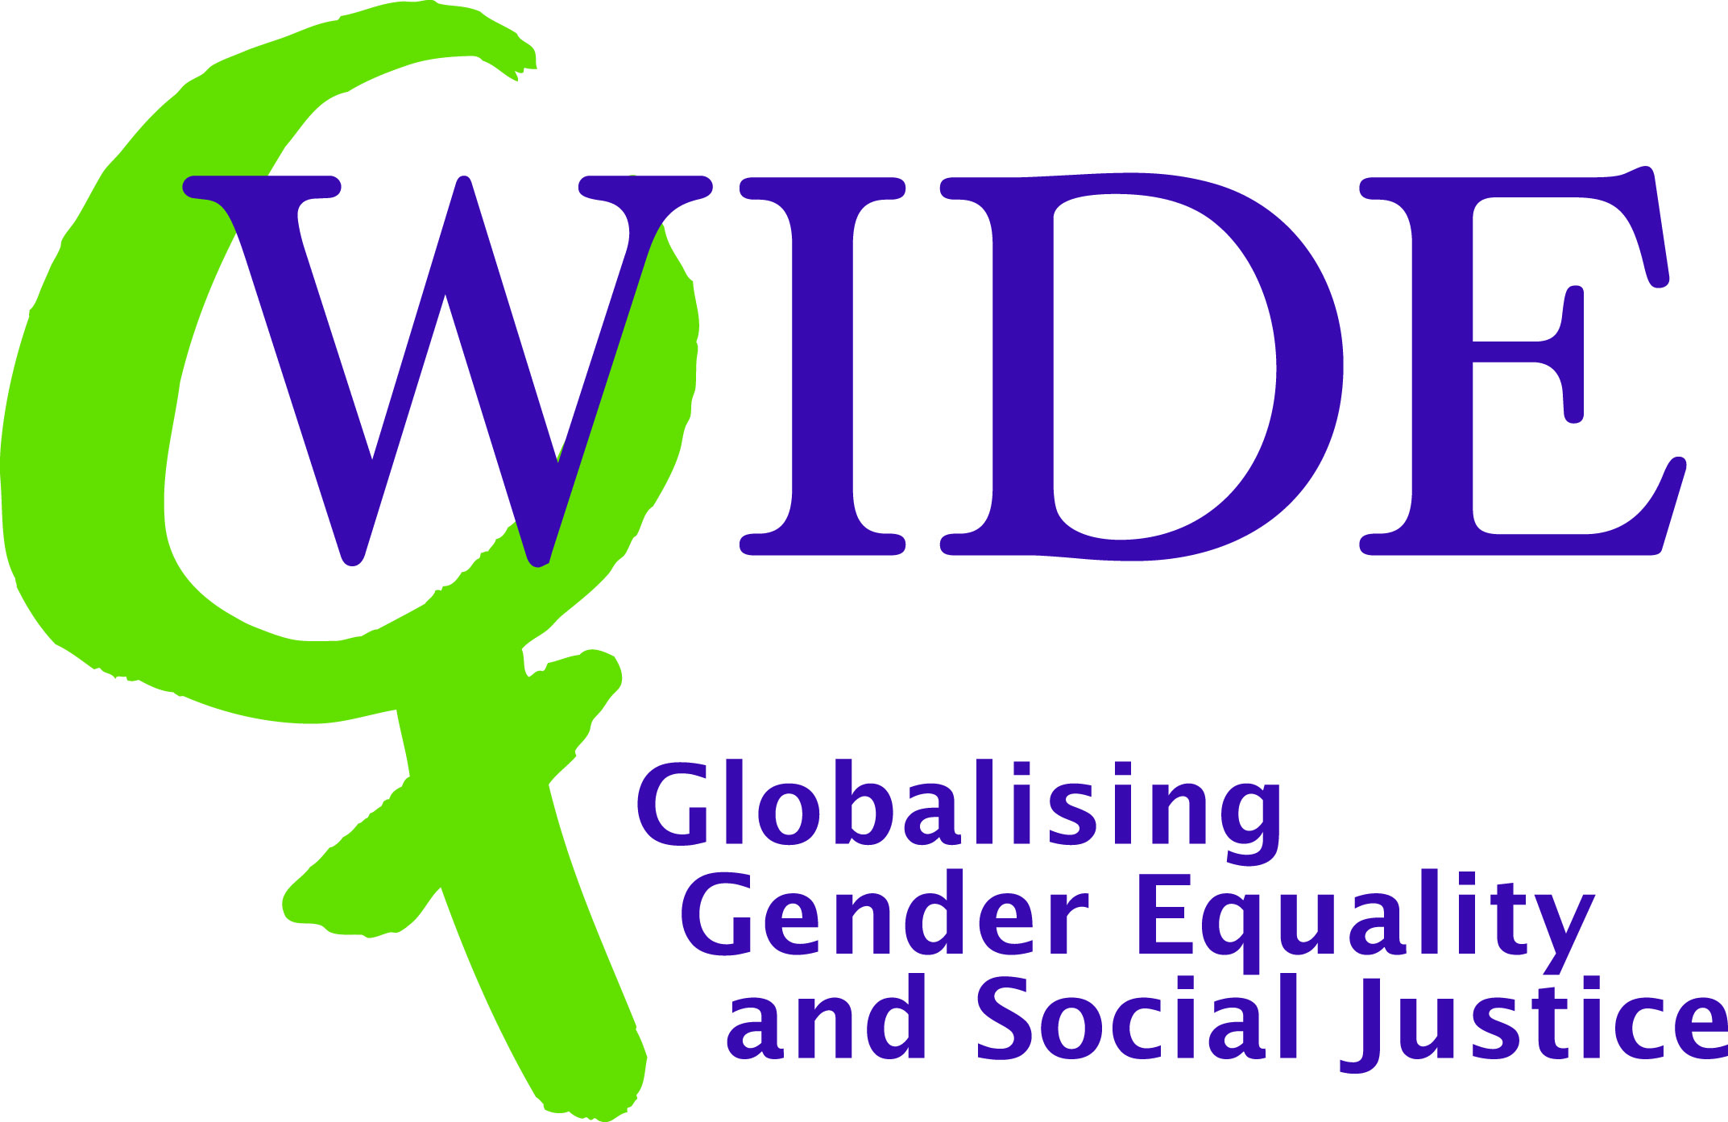
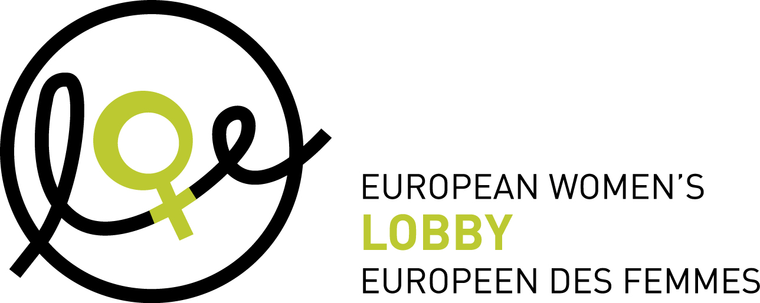

To celebrate the 30th anniversary of CEDAW, the Office of the United Nations High Commissioner for Human Rights (OHCHR), in partnership with the United Nations Economic Commission for Europe (ECE) and the United Nations Development Fund for Women (UNIFEM), organised a panel discussion on “Women and Migration” in Geneva with links to six video conference sites, based in: Chisinau, Moldova; Dushanbe, Tajikistan; Bishkek, Kyrgyzstan; Almaty, Kazakhstan; and Brussels, Belgium.

The panel guests came from different national and international contexts. They included members of the Committee on the Elimination of Discrimination against Women, Violet Awori and Violeta Neubauer; the Chair of the European Network of Migrant Women (ENoMW), Virginia Wangare Greiner; a representative from Babaylan Europe (the Philippine Women’s Network in Europe) and WIDE’s Danish Platform (KULU), Filomenita Mongaya Hogsholm and the Moldovan Deputy Minister of Labour and Social Protection, Sergiu Sainciuc. They provided expertise in the area of gender equality in general, the needs and experiences of migrant women in particular, as well as an economic dimension which enabled more in-depth discussion with particular reference to the financial crisis.

In addition to the introductory presentation by each panellist in Geneva, participants in the six video conference sites had the opportunity to address questions to the panel (although due to technical difficulties the participants in Kyrgyzstan were unfortunately unable to participate in this part of the panel event). The responses to these questions provided a wealth of information including recommendations for specific strategies for action by States, international organisations and NGOs.

The Brussels event was co-organised by UNIFEM, WIDE Network and the EWL, and was attended by representatives from UN entities, the European Commission, the European Parliament, NGOs and a women-focused documentation centre, RoSa. In Brussels, prior to the panel, the event was opened with a speech by MEP Franziska Katharina Brantner who provided the participants with an introduction to some of the issues faced by migrant women, with particular reference to European policy and practice.

Following the panel, the participants in Brussels engaged in a roundtable discussion. This discussion drew upon the dominant themes raised from the previous panel session as well as new information and experiences shared by the roundtable participants. Throughout the course of the panel and the roundtable discussion a list of recommendations was developed. These recommendations are presented in the latter part of this report.

- Defining the context: What is CEDAW?

Often described as an “International Bill of Rights for Women”, CEDAW protects women’s rights as human rights in order to advance gender equality. It addresses issues of fundamental importance to women and girls, including reproductive and maternal rights, domestic violence and human trafficking. It is explicit in its calls to break the barrier between the public and private spheres in order to ensure that women are protected in the home and the family, as these are sites of abuse which continue to remain invisible. Furthermore, CEDAW recognises the part that cultural and social traditions play in shaping gender roles. In response, it calls for the elimination of any practice which is based upon gender inequality.

CEDAW is a legally binding Treaty. It was adopted by the UN General Assembly in 1979 and came into force in 1981, once it had been ratified by 20 countries. Now, 186 countries are party to CEDAW, accounting for over 90% of UN member countries; however, many countries have included reservations in their agreement to the Treaty. Although all EU Member States have ratified CEDAW, the EU is not yet party to the Convention.

In October 1999 the UN General Assembly adopted the Optional Protocol to the Convention on the Elimination of All Forms of Discrimination against Women (OP-CEDAW). As of February 2008, there were 96 State Parties to the Optional Protocol to CEDAW. The Optional Protocol is a separate Treaty that supplements the CEDAW Convention. It does not introduce any new rights but strengthens the Convention by establishing two procedures: the Communications Procedure and the Inquiry Procedure. These can be used to tackle any violations of women’s human rights that are protected by CEDAW as they give the Committee on the Elimination of Discrimination Against Women the ability to accept and consider complaints from individuals or groups with reference to States that are party to the Protocol.

Of particular note in the context of this event is CEDAW’s General Recommendation no. 26 on Migrant Women Workers, which was made in 2008. This general recommendation highlights the non-gender neutral nature of migration and provides State parties with recommendations for action in order to respect the human rights of migrant women workers and to improve the lives of these women and their families.

- Brief overview of the situation of migrant women

Migration is a reality in Europe and the Commonwealth of Independent States (CIS). Europe and the CIS benefit considerably from the presence of migrant workers who are young and willing additions to both the labour market as well as to society as a whole. It is said that migrants comprise the world’s fifth largest State, of which 49% are women.

Migrant women face human rights abuses on a daily basis, including violence in their place of work (predominantly the home which is still often considered as a private sphere where the state should not interfere but where many migrant women work as au pairs and domestic workers ), poor levels of pay (as low as €1 per day) or no pay, unfair dismissal without pay, forced imprisonment, removal of identification documents by employers and agencies (including passports), separation from their children, severely limited access or no access to social goods (including healthcare) and trafficking into prostitution.

Children of migrant women are denied their human rights. The separation of women from their children is common. This separation of families denies women and their children the right to family life and undermines work-life reconciliation. Children who migrate with their mothers experience very low living standards and poor access to social goods such as education and healthcare.

Any action to improve the lives of migrant women and potential migrant women must recognise that migrant women are not a homogeneous group. There are different categories of migrants, including economic, humanitarian and environmental, documented and undocumented, as well as international and internal. Although some of their needs and experiences are the same, the diversity between women’s situations must be fully acknowledged and reflected in subsequent action.

Countries of origin, transit and destination all have a part to play in ensuring the rights of migrant women. Given the international nature of these issues, a coordinated approach is required, both horizontally between States and vertically through different levels and forms of administration (such as UN entities, NGOs and civil society organisations, trade unions and embassies). The movement of women from one country to another impacts both the sending and the receiving State. This relationship is particularly visible in the context of the financial crisis which has witnessed the value of remittances decrease as wages fall and the number of women dismissed from work goes up.

- Recommendations

The recommendations listed below developed during the course of both the panel event based in Geneva and the roundtable discussion in Brussels. Please note that these recommendations do not necessarily represent the opinions of the co-organisers of the event, UNIFEM, WIDE Network and the EWL.

- Strengthen the implementation of CEDAW:

- Fully implement CEDAW and strengthen State party involvement in the protection of migrant women in countries of transit and destination.
States must take decisive action in order to improve the lives of migrant women. States must ensure that all elements of CEDAW are implemented fully, creating legally binding action plans with budgets in order to promote the status of migrant women.

- Fully implement CEDAW in countries of origin.
Ensuring non-discrimination against women and equality between women and men must begin in the country of origin where it is essential that the human rights of women nationals are respected. Issues which cause women to migrate must be addressed. These issues include (but are not limited to) lack of employment, restricted access to social goods such as education and healthcare, and gender-based violence such as domestic violence and sexual harassment.

- State parties must be called to account for implementation failures.
The Committee on the Elimination of Discrimination Against Women (CEDAW Committee) and NGOs have an important role to play in highlighting State failures to implement CEDAW fully and in the spirit in which it was intended. The CEDAW Committee must employ a more dynamic and innovative approach to combating implementation failures and, where appropriate, particular reference to the Optional Protocol to CEDAW should be made.

- The European Union should ratify CEDAW.

- Review all policies that impact the lives of migrant women to ensure against discrimination and to secure equality for migrant women:

- Conduct gender-impact assessments systematically of all policies, whether at an international, European, national or local level, in countries of origin, transit or destination. Such assessments are effective tools to ensure that policies reflect the specific needs of migrant women and do not discriminate against them.

- Introduce a skills and education based approach to granting work permits.
Given labour market discrimination against women, a skills and education based approach to granting work permits would be less discriminatory against women than the dominant sector and earnings based approach which implicitly favour men and currently used in most European countries and promoted by the EU as well.

- Individualise rights and ensure that women have full access to social services.
The rights of migrant women must be individualised so that they have complete freedom from their husbands, partners and employers, so they are not dependent on another for a resident or work permit, or for access to services such as healthcare and education.

- Ensure the right to family life and full access to social services for their children.
Strategic action must be taken in both the countries of origin and destination to ensure the rights of women and their children, including the right to a family. Family reunification policies have to be reviewed to ensure that they do not have any direct or indirect discriminatory impact on migrant women. The country of destination must ensure that children of migrant women, independent of their legal status, have full and unrestricted access to social services, such as healthcare and education.

- Ensure the rights of all migrant women workers:

- Monitor recruitment agencies.
It is important to create a list of credible, legitimate and well-monitored recruitment agencies where women have free access to support and reliable information regarding job opportunities and employment rights. All recruitment agencies must take a gender sensitive approach to migrant workers. There are many illegitimate recruitment agencies which exploit migrant and potential migrant women: they charge high fees, remove identification documents including passports, and offer false jobs in order to traffic women into prostitution. These illegitimate recruitment agencies must be targeted, shut down, and the individuals and groups involved must be prosecuted.

- Recognise the private sphere as a place of work and ensure that all migrant domestic workers have a legally-binding contract.
Many migrant women work as au pairs and domestic workers in the home, where human rights abuses remain invisible, such as violence including sexual and physical abuse, deprivation of food and sleep, and forced imprisonment. Until the private household is recognised as a place of work, these women will remain unprotected. Contracts are fundamental to the protection of working migrant women, especially those working in the private sphere. Contracts must include stipulation of wage, working hours, tasks to be undertaken, night work and over-time. Women must not be obliged to live in the home of their employer and all identification documents must remain with the woman. Currently, many women migrant workers undertake multiple jobs (3-4) and are expected to be available 24 hours a day.

- Give migrant women workers the same status as other workers and ensure a role for trade unions.
National labour laws must afford migrant women workers the same status as their non-migrant counterparts at all stages of the work cycle, including equal protection in retirement. Migrant women workers must have access both to higher skilled jobs and to jobs in other sectors. Furthermore, migrant women must have access to protection via trade unions. Trade unions must be sensitive to the particular situations of migrant women who may fear to seek their assistance or be unaware of their existence.

- Guarantee the rights of undocumented workers.
The rights of undocumented workers must be protected both in the workplace and in wider society. Undocumented workers and their children must be ensured access to social services such as healthcare and education. All migrant women must be informed of their rights and be aware of how and where they can access support and information safely and securely.

- Target trafficking agencies and support victims of trafficking, including children.
A list of legitimate recruitment agencies must be drawn up to guard against women receiving false information about jobs abroad and subsequently being trafficked without their knowledge. All agencies must be monitored and prosecutions must be pursued as required. Furthermore, the significant gaps in the legal protection for victims of trafficking (including children) must be addressed. These gaps include (but are not limited to) the lack of rights to remain in the country into which a woman has been trafficked and also the lack of support for women who are acting as witnesses in a prosecution case. For further information please refer to the Council of Europe’s Convention on Action Against Trafficking in Human Beings.

- Inform migrant women and potential migrant women of their rights, as well as the potential risks and opportunities of migrating, and establish referral mechanisms.
Prior to departure migrant women and potential migrant women must be informed of their rights and how to claim their rights. They must also be given information on jobs abroad. State parties, recruitment agencies, NGOs and the media must all play a role in the dissemination of this information. Importantly, all information must be provided in the mother language of the migrant woman. There must also be multiple contact points throughout all stages of migration where officials are approachable and responsive to the needs to migrant women, whether they are documented or undocumented. Referral mechanisms must be established so that migrant women are directed towards the appropriate support access point. A visible role for embassies must be established. This should result in migrant women registering their presence with trained diplomatic staff upon arrival in the country of destination.

- Promote bottom-up action through supporting migrant women’s community groups.
Real change for migrant women will be promoted through a bottom-up approach. Migrant women must be provided with the necessary financial and social resources, as well as information, so they can develop, articulate and advance their own agenda for change. Babaylan Europe (the Philippine Women’s Network in Europe) and the European Network of Migrant Women (ENoMW) are examples of such networks which have been created to bring together different voices in Europe in order to develop a single strategy with specific demands.

- Introduce and increase communication between NGOs, State bodies and the UN.
Communication links must be strengthened or established between UN entities, State bodies and NGOs to ensure a coordinated approach to improving the lives of migrant women and potential migrant women. These communication links must also include inter-ministerial networks, inter-State dialogue, engaging with trade unions as well as a more robust communications network between NGOs.

- Provide an evidence-based information on migrant women:

- Collect comprehensive data and monitor all stages of migration.
Both quantitative and qualitative data must be collected to provide reliable information on the situation of migrant women, beginning with response to the question, “Why are women moving?”. Research must address where women migrate from and to, as well as the risks and the opportunities of migrating. This information must be widely disseminated in order to influence subsequent policy and action.

- Combat stereotypes and raise awareness.
In conjunction with UN entities, State bodies and NGOs, the media and communications networks must be encouraged to promote a positive view of migrants, raising awareness of the valuable contributions migrants make to the social and economic life of a country. Stereotypes must be challenged and migrant women given a human face: the reality of migrant women’s lives must be made known. This will go some way towards combating the racism which remains a persistent problem for migrant women and their families.

- Highlighting EWL, WIDE and UNIFEM work on women and migration in 2010

- EWL will keep actively lobbying the EU institutions to ensure a gender perspective in all initiatives related to immigration, asylum and integration.
- EWL will organise with other European networks a seminar on undocumented migrant women and men and issues of poverty and social exclusion in the framework of the European Year for Combating Poverty and Social Exclusion.
- EWL will release a joint publication with the European Network of Migrant Women looking critically at integration policies from the perspective of migrant women.
- EWL will keep supporting the development of the European Network of Migrant women and ensure that the voices of migrant women’s organisations are heard at the European level in the framework of EWL Project “Equal Rights. Equal Voices. Migrant Women in the European Union”.

- WIDE Annual Conference 2010 held in June in Romania and hosted by the Romanian organisation AUR (a member of WIDE’s regional platform KARAT) will be focusing on women and migration.
- WIDE will release a study on women’s migration in the context of globalisation. The study aims to give an introduction to the linkages between gender-trade-development-migration and labour issues and seeks to highlight the structural causes of women’s (workers) migration, its contribution to sustaining the current economic model (formal/informal, productive/reproductive work) and main social and economic development impacts. The study draws attention to the inconsistencies and incoherence of the EU’s development and human and women’s rights commitments and its migration policy, discourse and practice.
- Some of WIDE’s members such as WIDE’s Danish platform KULU, BABAYLAN - the Philippine Women's Network in Europe and TIYE International in the Netherlands are working on women’s migration.

UNIFEM will continue to promote the right of migrant workers in line with the global trends and agreements, with a particular emphasis in the Millennium Development Goals.

- UNIFEM is starting a regional consultation process in the Central and Eastern European countries and Commonwealth of Independent States (CEE/CIS) on female domestic workers, which will allow mapping initiatives related to domestic work (including migrant or non-migrant or internal migrant) by United Nations and other development partners; identifying the countries in the region, including European Union Member States, having legislation on the private household being considered a workplace and compiling available data and statistics on domestic workers in the region. This preliminary work will lead to a regional programme on domestic workers for Europe and the CIS region, with a focus on the private household being considered a place of work.

- Building on previous work, UNIFEM is launching the third phase of its Asia-Pacific and Arab States Regional Programme on Empowering Women Migrant Workers in Asia for the years 2009-2013, aiming at empowering women migrant workers from a gender and rights based approach by addressing the global/regional and multi-sectoral dimensions of migration. The project will promote sustained policy dialogue and develop models of good practice of bilateral/multilateral collaboration between countries of origin and employment; advocate for legal reform; promote and strengthen the rights and socio-economic security of women migrant workers; contribute to the knowledge base on gender, migration and development and develop mechanisms to monitor the effectiveness of international and regional agreements, national laws policies and programmes in protecting and empowering women migrant workers.

Useful links and references

CEDAW links

- CEDAW (1979) on the OHCHR website: http://www2.ohchr.org/english/law/cedaw.htm

- Optional Protocol to CEDAW: http://www.un.org/womenwatch/daw/cedaw/protocol/

- CEDAW’s General Recommendation no. 26 on Migrant Women Workers: http://www2.ohchr.org/english/bodies/cedaw/docs/GR_26_on_women_migrant_workers_en.pdf

- WIDE Network’s CEDAW blog: http://cedaw30.wordpress.com/

- Karat Coalition webpage about CEDAW: http://www.karat.org/op_cedaw/cedaw-convention.html

Links referenced in the text

Babaylan Europe (the Philippine Women’s Network in Europe): http://www.babaylan-europe.org/

European Network of Migrant Women (ENoMW): http://www.migrantwomennetwork.org/

OSCE Guide on Gender-Sensitive Labour Migration Policies, 2009:
http://www.osce.org/publications/eea/2009/05/37689_1289_en.pdf

UN International Convention on the Protection of the Rights of All Migrant Workers and Members of Their Families (entered into force on 1 July 2003): http://www.un.org/documents/ga/res/45/a45r158.htm

Council of Europe Convention on Action Against Trafficking in Human Beings (entered into force on 1 February 2008): http://www.coe.int/t/dghl/monitoring/trafficking/Docs/Convntn/default_en.asp

KULU - Women and Development : http://kulu.dk/in_english.htm

Links to co-organising bodies of Brussels event

EWL website: http://www.womenlobby.org/site/

UNIFEM website: http://www.unifem.org/

WIDE Network website: http://www.wide-network.org/

Links to other reports from the event:

RoSa Documentation Centre report written by Brigitte Rys (in Dutch):
http://www.rosadoc.be/pdf/verslagen/arbeidsmigratie.pdf

UN Non-Governmental Liaison Service report (in English):
http://www.un-ngls.org/spip.php?article1682

See the report of the event in Geneva at : http://www.un-ngls.org/spip.php?article1682

