APPLICATION FORM INTERNSHIP
GENDER BUDGETING PROJECT
Deadline 16 January 2019, 23:59 CET.
EUROPEAN WOMEN’S LOBBY SECRETARIAT, BRUSSELS
6 MONTHS – FULL TIME: MARCH – AUGUST 2019

- General information:

Name:

Telephone:

Email address:

2. Motivation and competences:

In no more than 120 words, please explain why you want to do an internship with the European Women’s Lobby?
In no more than 120 words, please describe your experience of involvement with women’s rights and gender equality.
In no more than 120 words, please share your analysis of the main challenges to women’s rights in Europe today.
In no more than 120 words, can you describe a project that you were involved in/managed, how did you deal with multiple stakeholders and tasks? What were the challenges and how did you overcome them?

In no more than 120 words, in your view, what is gender budgeting and why is it relevant?

3. References:
Please provide the name, function, email address and telephone number of two referees, one of whom should be your present or most recent employer or an academic referee if more appropriate. Referees will not be contacted without your prior permission.

a)

b)

4. Starting date:
If selected, when would you be able to take up this internship with the EWL?

5) Any other information, training etc. relevant to the application (no more than 150 words)

……………………………………………………………………………………………………………………………………………………………………..

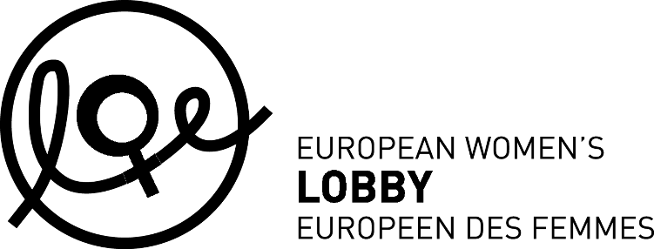
www.womenlobby.org

Candidates are requested to submit

- A CV in Word or PDF (name your file as follow ’Last name-CV’)
- This filled-in application form in Word or PDF (name your file as follow ’Last name-application form-title of preferred internship’)

Send this all by e-mail to jobs@localknowledge.be mentioning in the subject line:

‘Application for EWL internship 2019 / YOUR NAME’

Applications not respecting the instructions for completing and submitting the application will not be considered.

Closing date for applications is 16 January at 23:59 CET.

