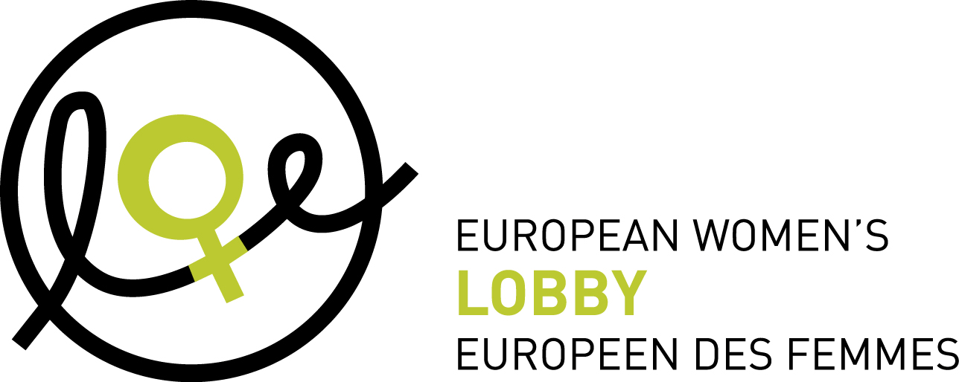

CALL FOR APPLICATIONS

EXTERNAL CONSULTANT - RESEARCHER

Do you want to do research and develop a framework of principles for feminist sexuality and relationship education in Europe? If yes, this research opportunity is for you!

The European Women’s Lobby (EWL) is the largest umbrella organisation of women’s associations in the European Union, gathering over 2000 women’s associations. The EWL has members in all 28 EU Member States and three of the candidate countries. The EWL campaigns for a feminist Europe, which promotes women’s rights and equality between women and men in the European Union in line with our organisational strategic framework “Together For A Feminist Europe!”.

The EWL is looking for an experienced and senior consultant to compile a report on EWL’s Feminist Principles on Sexuality Education by consolidating existing research previously conducted with our members across Europe along with updated information, comparative review of relevant research and documentation, and limited follow up with key stakeholders; write an analysis report which will set out our Principles and will lay-out a series of recommendations to be considered in order to establish a best-practice model of feminist sexuality and relationship education across Europe.

We are looking for an outstanding professional with a high level of writing skills and an understanding of the political and cultural context in which feminist sexuality and relationship education must be considered. As an intersectional feminist organisation, we are seeking to build a feminist Europe that represents Europe in all of its diversity. As such, people/women of color and from ethnic minority groups, people with disabilities, people from the LGBT+ community and people coming from marginalized groups are especially encouraged to apply.

HOW TO APPLY
Interested candidates are requested to submit an application to the European Women’s Lobby via email to catriona.graham@womenlobby.org along with a
- one-page cover letter explaining your motivation and alignment with our research needs;
- copy of your CV; and
- 2-page proposal for how this work will be carried out, detailing the timing and the methodology.
Please include in the e-mail subject line: “Application for Research Consultant: EWL’s Feminist Principles in Sexuality Education, and YOUR NAME”.
Closing date for applications is 14 August 2019 at midnight CET.
Total budget for the researcher’s work will not exceed 4,500 euros including VAT in total.
Applications not respecting the instructions will not be considered.
Interviews of shortlisted candidates will be held the week of 19 August 2019. Interviews through Skype are possible for candidates who are not able to come to Brussels in person. The ideal candidate should be able to start as soon as possible.

1. Background

This mapping project is part of our campaign planning process on the issue of sexuality education in Europe. Based on EWL Strategic Framework 2016-2020, the EWL has decided to work towards the following goal: the EU has adopted strategies and programmes to support the adoption and implementation of sex education and relationship schemes in formal and non-formal education for young people.
The final report on the state of sexuality education in Europe will gather and analyse information provided by the EWL’s national coordinations and other national organisations from across 27 European countries.
The first stage of this process was a Member State level mapping of sexuality education practices, which took place in 2015-2016. was structured around 5 questions, which will continue as key themes in our report:
1. The ideal situation: this question will help to frame a collective vision of what we want to see. Why is sexuality education an issue? What is the change we want to see?
2. The current situation: to set the context at national level in terms of curriculum; decision-making; legislative state of play; content of the policies/measures; etc to define who has power to make change; what are the stakeholders in place; key champions and allies.
3. Information on the context in your country: what is the role of the feminist argument for sexuality education and making links with other areas of society and life: power, oppression, consent, justice and equality.
4. Innovative practices: this question brings practical great examples you want to share, which can be an inspiration for our work at European and national level.
5. Demands: What are the key changes that need to happen to realise feminist sexuality education practices across Europe? How do we ensure this benefits all girls and women? What are the first steps that can be taken? What opportunities exist at national and European levels for impact?
Sexuality education seeks to equip young people with the knowledge, life skills, attitudes and positive values they need to understand and enjoy their sexuality – physically and emotionally. It should address both individual sexuality and also to promote safe and fulfilling relationships and to take responsibility for their own and other people’s sexual health and well-being. It must help young people to acquire accurate information on sexual and reproductive rights. A comprehensive sexuality education covers a broad range of issues relating to both the physical and biological aspects of sexuality and the emotional and social aspects.
From a feminist perspective, sexuality education is a key tool to promote empowerment and gender equality and is a matter of women’s rights.
Good quality sexuality education programmes that includes a feminist and intersectional perspective can have many purposes in terms of equality. This may include:
• combat and counter sexism and stereotypes and to question normative gender roles and change mentalities while promoting gender equality values and attitudes which underpin violence against women and girls.
• question hetero-normativity and promote respectful attitudes towards different forms of sexuality. This will lead to a decrease in homophobia and lesbophobia.
• promote the full enjoyment of sexual and reproductive health and rights, including providing information on the reproductive system, skills and access to contraceptive measures. This will lead to a decrease in teenage pregnancies and abortions and a decrease of STIs/HIV infections.
• promote a positive body image, self-confidence and self-esteem and counterbalance the negative effects of the widespread image of women portrayed in media and pornography (hyper-sexualisation and commodification of women and girls’ bodies).
• empower women and boys to enjoy their sexuality stressing the importance of consent and self-awareness on their rights. Promote respect, acceptance, tolerance and empathy for others. Women gain higher power or control in their sexual relationships and men don’t feel pressure to fulfill male stereotypes and to engage in controlling or harmful behaviors.
• prevent different forms of VAWG : domestic violence, sexual harassment, sexual abuse and rape, prostitution and sexual exploitation, FGM, child marriage, etc.
However, as previous studies have shown, the content and the quality of sexuality education varies greatly from country to country. In many countries, sexuality education rarely goes beyond biological aspects of sex and reproduction, lacking more guidance on the emotional and social aspects of sexual relationships.
The lack of comprehensive, good quality and feminist sexuality education can be very damaging in a world where the culture of violence in the media and the sexualisation of women and girls are major factors contributing to the perpetration of violence against women and girls. Specifically, the dominance of online pornography is very negatively affecting sexual relationships and behaviours portraying unrealistic attitudes about sex; sexist gender role attitudes (e.g. male dominance and female submission); beliefs that women are sex objects; explicitly depicting sexual violence against women and girls, etc.
This is why the European Women’s Lobby is committed to the promotion of positive, radical, inclusive feminist sexuality education.
The full results of the national research, initial analysis and proposed report structure will be shared upon commencement of the research.

2. Purpose, Focus and Task
Purpose: Create a report setting out EWL’s Feminist Principles in Sexuality and Relationship Education. This report will contribute for the design of EWL’s position on sexuality education by defining EWL’s vision and strategy and by setting a consensus on the language that should be utilised across Europe by our full members.
It will: gather common threads and point out main challenges; provide advice on what is the best way to implement sexuality education; shed the light on good practices and positive messaging that should be adopted; identify the strategies and actions to be undertaken as part of EWL general campaign on sexuality education.

3. Scope of Work, Methodology
The researcher will review data already gathered from across the national EWL members, and when necessary, conduct follow-up questions with key target groups or relevant European member organisations.
The researcher will also review the existing key international guideline documents on best practices in sexuality education to ensure alignment and advancement of our Principles. We, therefore, expect the Consultant to:
- consolidate research conducted around the theme of sexuality education in Europe, highlighting the gaps, challenges, ideas for new standards, opportunities etc which members have identified and in Europe;
- compare and analyse findings in relation to existing data and information; and
- conduct follow up questions (maximum 10) with key stakeholders (relevant members, engaged groups and partners);
- present resulting research report to the Sexuality Education sub-committee of the EWL Taskforce on SRHR and Sexual Exploitation.

4. Results and Deliverables
A 16-page content analysis including:
- EWL’s Feminist Principles in Sexuality Education

- Context and mapping of:
  - the state of sexuality education around Europe;
  - build up holistic, rights–based, participatory and comprehensive sexuality education programmes for schools – from the content to the practice; and
  - ensuring feminism and social reform, including an end to all forms of violence against women, is a core aspect of sexuality education.

- Recommendations
  - A series of scenarios and recommendations to be considered; and
  - Key allies and decision makers identified for realizing same.

5. Duration and reporting of the research
The expected report to be submitted to EWL no later than the 20th of September.
The Consultant will coordinate with and report to Catríona Graham at the European Women’s Lobby.

6. Profile, essential skills and attributes
A senior consultant that will entail skills from an individual who has experience and can demonstrate the following:
- Strong commitment to intersectional feminism and women’s rights;
- Deep respect for diversity, and demonstrated commitment to the promotion of a diverse and inclusive Europe;
- Knowledge of sexuality education practices in Europe;
- Experience in political advocacy or policy development;
- Ability to work efficiently and responsively within a multicultural environment;
- Ability to write clearly and produce quality work in English and synthesise a range of other research within a deadline; and
- Experienced communicator and in working virtually.

7. Details of consultant fees and agreements
Total budget for the researcher’s work will not exceed 4,000 euros including VAT in total.
The details for entering into agreement for consultant fees, tasks and responsibilities, accountabilities and binding agreements will be discussed during the application process and are to be entered into contract between the European Women’s Lobby and the selected candidate with an attached Terms of Reference (ToR).

