CALL FOR APPLICATIONS
Finance and Administration Director
European Women’s Lobby Secretariat Brussels
Preferred start date: June 2020
Deadline for applications: 23 February 2020 23:59 CET
DO YOU WANT TO WORK FOR A FEMINIST EUROPE?
You are in the right place! The European Women’s Lobby (EWL) is the largest umbrella organisation of women’s organisations in the European Union, gathering over 2000 women’s associations. The EWL has members in the EU Member States and 3 of the candidate countries as well as 19 European wide members. The EWL campaigns for a feminist Europe, which promotes women’s rights and equality between women and men in the European Union.

YOU COULD BE THE PERSON WE ARE LOOKING FOR!
We are looking for a Finance and Administration Director to oversee the smooth running of the EWL Secretariat, including ensuring sound financial and human resources management policies in line with the EWL’s feminist culture and the Belgian legal requirements.
This person will also be responsible for managing, coaching and empowering a team of 2 admin and events staff to support the smooth running of the EWL office, finance and events. In addition to having the relevant experience in finance and administration work (outlined below), the Finance and Administration Director needs to have strong interpersonal skills, with demonstrated experience in working collaboratively and establishing trust with colleagues, members, and external suppliers.

As an inclusive feminist organisation, we are seeking to build an organisation that represents Europe in all of its diversity. We believe candidates with diverse experiences and backgrounds bring real added value to our existing feminist culture. As such, we strongly encourage applicants from underrepresented and marginalised groups, sexualities or nationalities to apply: for example candidates from ethnic minority groups, people with disabilities, people with caring responsibilities etc.

HOW TO APPLY
Please read the instructions and the role description, necessary skills & attributes and conditions carefully before you apply. As we often receive a large number of applications, we will give priority to those who can demonstrate that they meet the criteria listed. We know you are busy, and we appreciate you taking the time to apply!

Interested candidates are requested to submit to the European Women’s Lobby jobs@womenlobby.org

- Your 2 pager CV in Word or PDF (name your file as follow 'Last name-CV')
- A two page cover letter outlining your motivation and your experience relevant to the role (name your file as follow 'Last name-cover letter”)

Please keep in mind that only applications transmitted via the correct procedure will be considered.

Closing date for applications is 23 February 2020 23:59 CET. Interviews of shortlisted candidates will be held on w/c 16 March 2020. Interviews through Skype are possible for candidates who are not able to come to Brussels in person.

ROLE DESCRIPTION
Role Title: Finance and Administration Director
Reporting To: Secretary General
Location: EWL Secretariat, Brussels

Role Purpose:
The role is a senior post within the European Women’s Lobby (EWL) Secretariat to be based in Brussels, with the purpose of:
- Overseeing the smooth running of the EWL Secretariat, including ensuring sound financial and human resources management policies in line with the EWL’s feminist culture and the Belgian legal requirements.
- leading the finance and admin hub in the effective and efficient delivery and implementation of plans, specifically, to supervise, line manage and coach the finance and admin hub (FAH) staff (currently 2.5 FTE) in line with the EWL Human Resources and feminist leadership principles; and
- Taking part of the Strategic Management Team (SMT) to contribute to the strategic management and leadership of the EWL Secretariat in the effective delivery of the EWL’s goals and objectives;
- Developing and fine-tuning our systems and processes to ensure that our information is organised effectively and held securely across our entire organisation.

Overall Responsibilities
- FINANCE MANAGEMENT (60%): ensure the sound financial management of the organisation in line with Belgian legal requirements and EWL feminist culture, specifically to:
- responsible for the daily financial management of the EWL including: payments, accountancy, invoices, suppliers, financial statements and cash flow;
- lead financial accountability processes and development of financial policies in compliance to Belgian laws to ensure compliance with EWL finance procedures by staff, members, and governing bodies;
- manage and oversee external accounting consultancy to ensure correct and transparent financial management and production of the annual statutory accounts and annual global overview of finances for review by the Secretary General and Board;
- ensure high quality and timely production of financial papers providing key financial information to ensure sound decision-making for EWL’s governing bodies and statutory meetings;
- provide key advice and guidance for the SMT and the Treasurer on finance and administration related matters to manage reputational and financial risk and opportunities, including when necessary support the Treasurer in preparing presentations for financial information for the governing bodies; and
- work closely with the Programme Director to support the development of budgets and financial reports for funders including the European Commission.

- OFFICE MANAGEMENT AND EVENTS (25%): support the Secretary General in the overall management of the office and events, including through supervising specifically to:
- work collaboratively with others in the secretariat to ensure that the administration and day-to-day management of the EWL Secretariat runs smoothly, including managing relations with Belgian authorities and external suppliers such as insurance, bank, building owner, etc;
- lead EWL in ensuring that our ICT system and operations are secure, effective and optimal for use; including leadership on Office 365, risk management of IT vulnerability, GDPR, contact management systems etc;
- coordinate the negotiation and purchase of procurement items, and ensure compliance as outlined in the finance manual;
- coordinate the negotiation and contractual requirements for property leases and other commitments;
- ensure sound data protection procedures and policies are in place and implemented
- ensure support and coordination for logistics and administrative needs for all EWL events and key priority meetings.

- HUMAN RESOURCES ADMINISTRATION (15%): support the Secretary General in the administration of the organisation’s human resources in order to make sound decisions in line with EWL’s feminist culture and with the Belgian legal requirements, specifically to:
- develop and implement HR policies including when necessary maintain contact with Belgian Authorities to ensure compliance and records;
- manage the payroll in close contact with social secretariat (delivery of official documents and answers to requests), including the management of extra-legal benefit and insurances, and when appropriate ensure dissemination and follow-up of administrative documents to staff and the handling of staff requests;
- prepare and update employment and internship contracts;
- work with external Human Resources consultant in the development and implementation of Human Resources policies including to keep up to date information on social legislation, internal rules and work regulations.

SKILLS & ATTRIBUTES
EWL embraces a feminist culture that imbibes our core values, vision and mission. We are, therefore, seeking a future colleague who will embrace and commit to our EWL Feminist Culture and is aligned with EWL’s positions, especially on male violence against women and prostitution as per the EWL position paper “Towards a Europe Free from all Forms of Male Violence Against Women”.

ESSENTIAL
We are especially hoping that our future colleague can demonstrate the following skills and experiences:
- experience and knowledge on:
  - financial management in a previous or present role: whole accountancy and finance management cycle and is comfortable in dealing with all of these issues across multiple currencies;
  - accounting systems, ISABEL, WinBooks software, Office 365 (including outlook and excel) and other cloud-based finance and knowledge management systems including strong command of ICT and computer systems in general;
  - minimum of 7 years of professional or volunteer experience;
  - working within the Belgian regulatory framework in finance and human resources;
  - management of staff/interns/volunteers as well as management of relations with contractors and suppliers;
  - spoken and written English as essential; excellent written and spoken French required.

- can demonstrate ability to:
  - embrace ways of working that contributes to a nurturing feminist leadership;
  - work collaboratively and positively within a team and inter-teams to ensure effective, efficient and timely delivery of work priorities and commitments;
  - develop and roll out improved processes for finance and administration
  - have strategic financial thinking and strong attention to detail in order to uphold a culture of accountability and fiscal controls across the organisation;
  - think ahead to identify and manage risks associated with finance and administration; and
  - work well under pressure, is resilient, and can manage changing demands and priorities when required by internal/external events or strategic opportunities.

DESIRED SKILLS AND ATTRIBUTES

- Knowledge of accounting systems such as WEMSY and Winbooks;
- Previous experience working with financial reporting to the European Commission;
- Previous experience in an NGO or social movement/network ;
- Familiarity with accountancy budgeting and database software;
- Demonstrated experience in movement building;
- Experience with human resources administration;
- Familiarity with the Belgian law for AIBSLs;
- Knowledge of Dutch is a plus.

WHAT WE OFFER
- The opportunity to oversee the finance and office management work in the leading European women’s rights organisation, protecting and promoting the rights of millions of women in 31 countries;
- A relaxed office environment, with a great deal of personal autonomy, flexibility, and room for creativity and innovation;
- A friendly and lively multicultural environment in a small team of 14 dedicated feminists;
- Feminist working culture with strong HR management framework committed to staff development and personal evolution;
- The possibility to contribute to the leadership of the governance of an umbrella movement organization operating at EU level;
- A long-term contract under Belgian law starting June 2020;
- A gross salary of 3,500 EUR/month plus benefits: 13th month, “pécule de vacances”, pension (assurance groupe), lunch vouchers and reimbursement of local transportation.

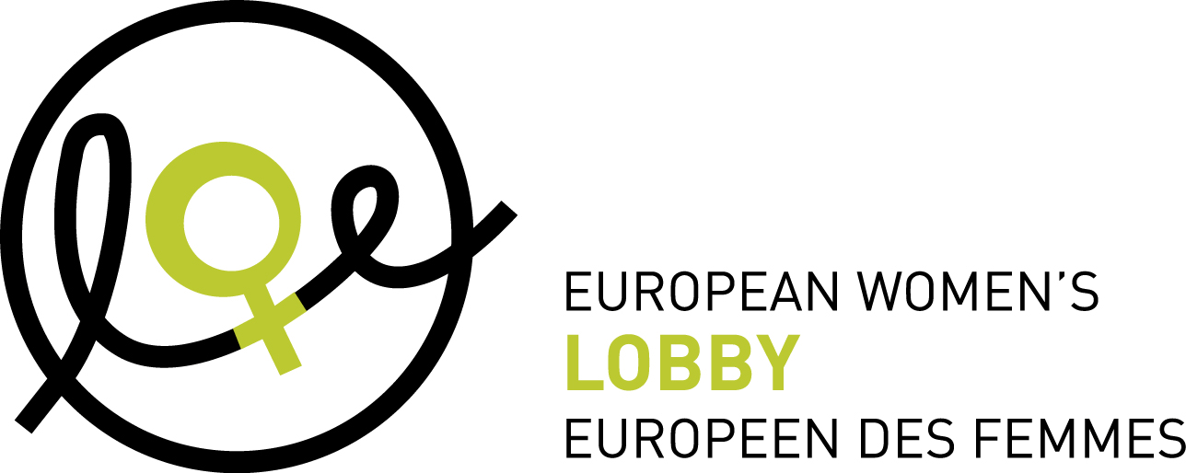

Funded by the Rights, Equality & Citizenship Programme

